MULTISITE GRANT MANAGEMENT SYSTEM

User Management

User Guide Document

Ver. 1.4

Version History
Date | Description
21-Oct-2010 | First draft
10-Feb-2011 | Added new sections; term change: “Masters” to “Settings”

Table of Contents

Version History 2
1 Introduction 4
1.1 Purpose 4
2 User Management 4
2.1 Add Role Privileges 4
2.2 Access Permission 5
2.3 Project Permission 5

Introduction

Purpose

This document provides the step-by-step instructions for the site administrator to maintain user records, administer privileges and add/delete users through the Multisite Grant Management System.

Please note that this is a ‘living document’ and the specification will change, continuously, as the project proceeds. More details will be added and the existing information edited as the requirements, scenarios and use cases evolve in the course of the project.

User Management

Add Role Privileges
Newly created Role don’t have any privilege now, need to give it manualy.
- Select the role to which all the privileges need to be given. Click the create button and all the privileges will be given to that role.

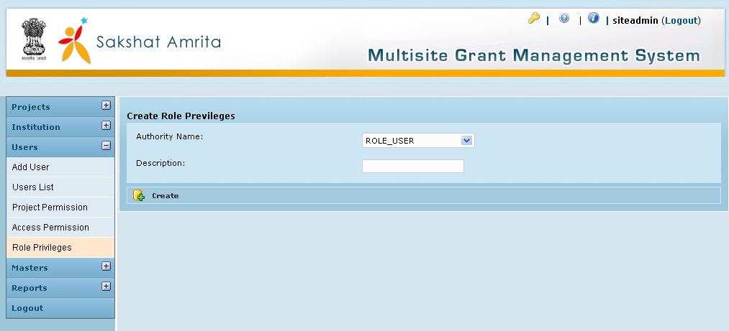

Access Permission
The site admin can give privileges on each action to the users on the basis of roles. Now the system gives all access to new roles created. Later the site admin can change as required.
- Select the role and the domain needed.
- The actions under that domain on which the selected role had privileges will be listed in the right hand side and other actions on the left hand side.
To add the privileges click the arrow button towards right hand side and to remove the privileges click the arrow button towards left hand side.

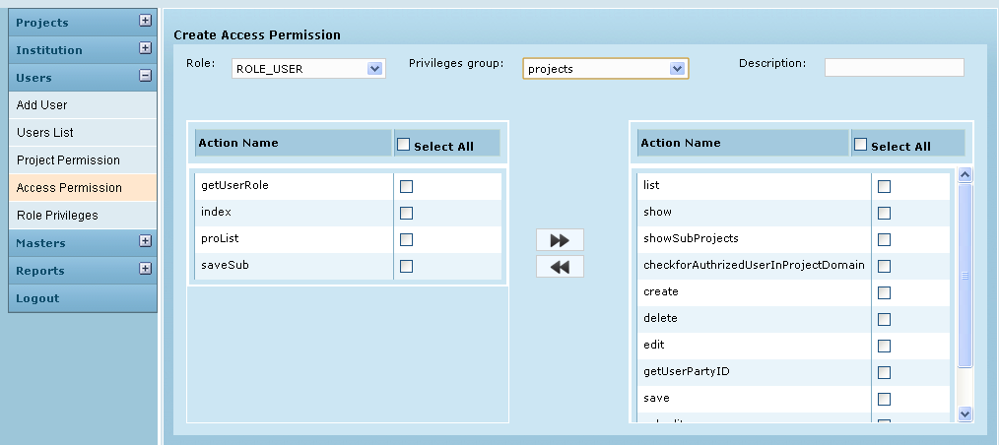

Project Permission
- Select the user from the list.
- All the projects created by the siteadmin will be listed there. The project which is already assigned to that particular user will be listed in the right hand side and others in the left hand side.
- The siteadmin can assign or unassigned the projects to the users by clicking the appropriate direction button.
- To assign the projects select the needed project and click the arrow button towards right hand side and to unassign the projects click the arrow button towards left hand side
Logout from Site Admins session

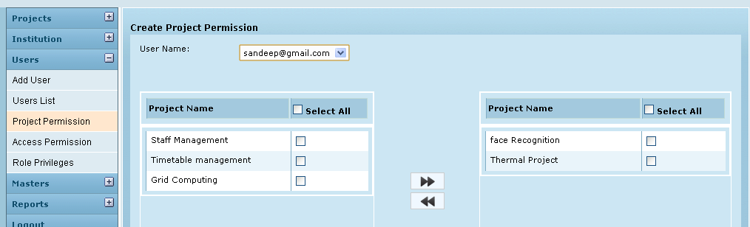

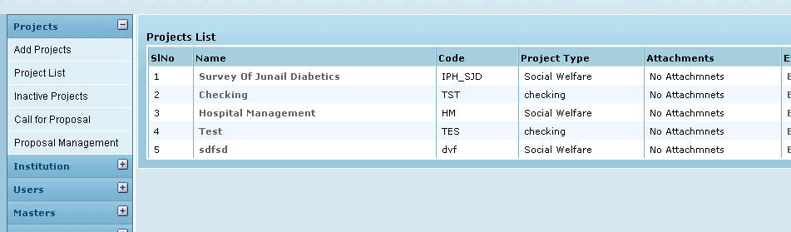

Log in to Project Admins session using the user name and password created by Site Admin. The projects which have the permission for that will be listed in their session.

